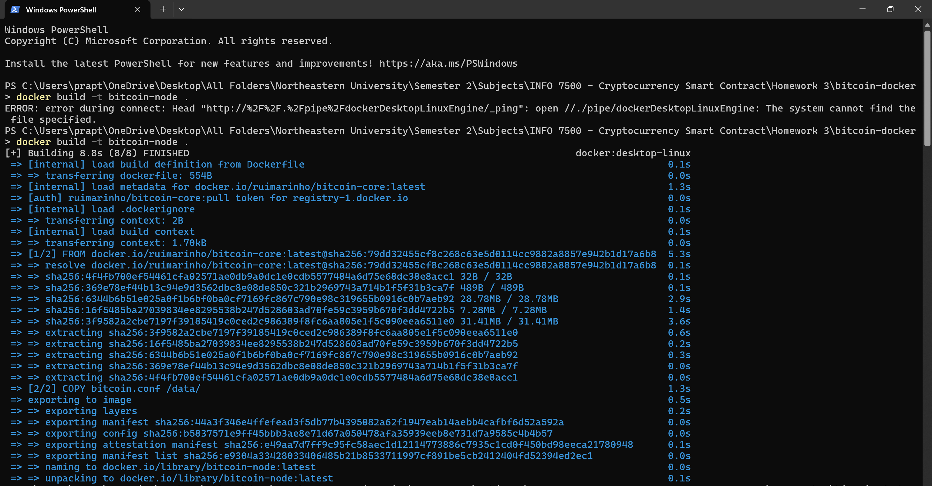

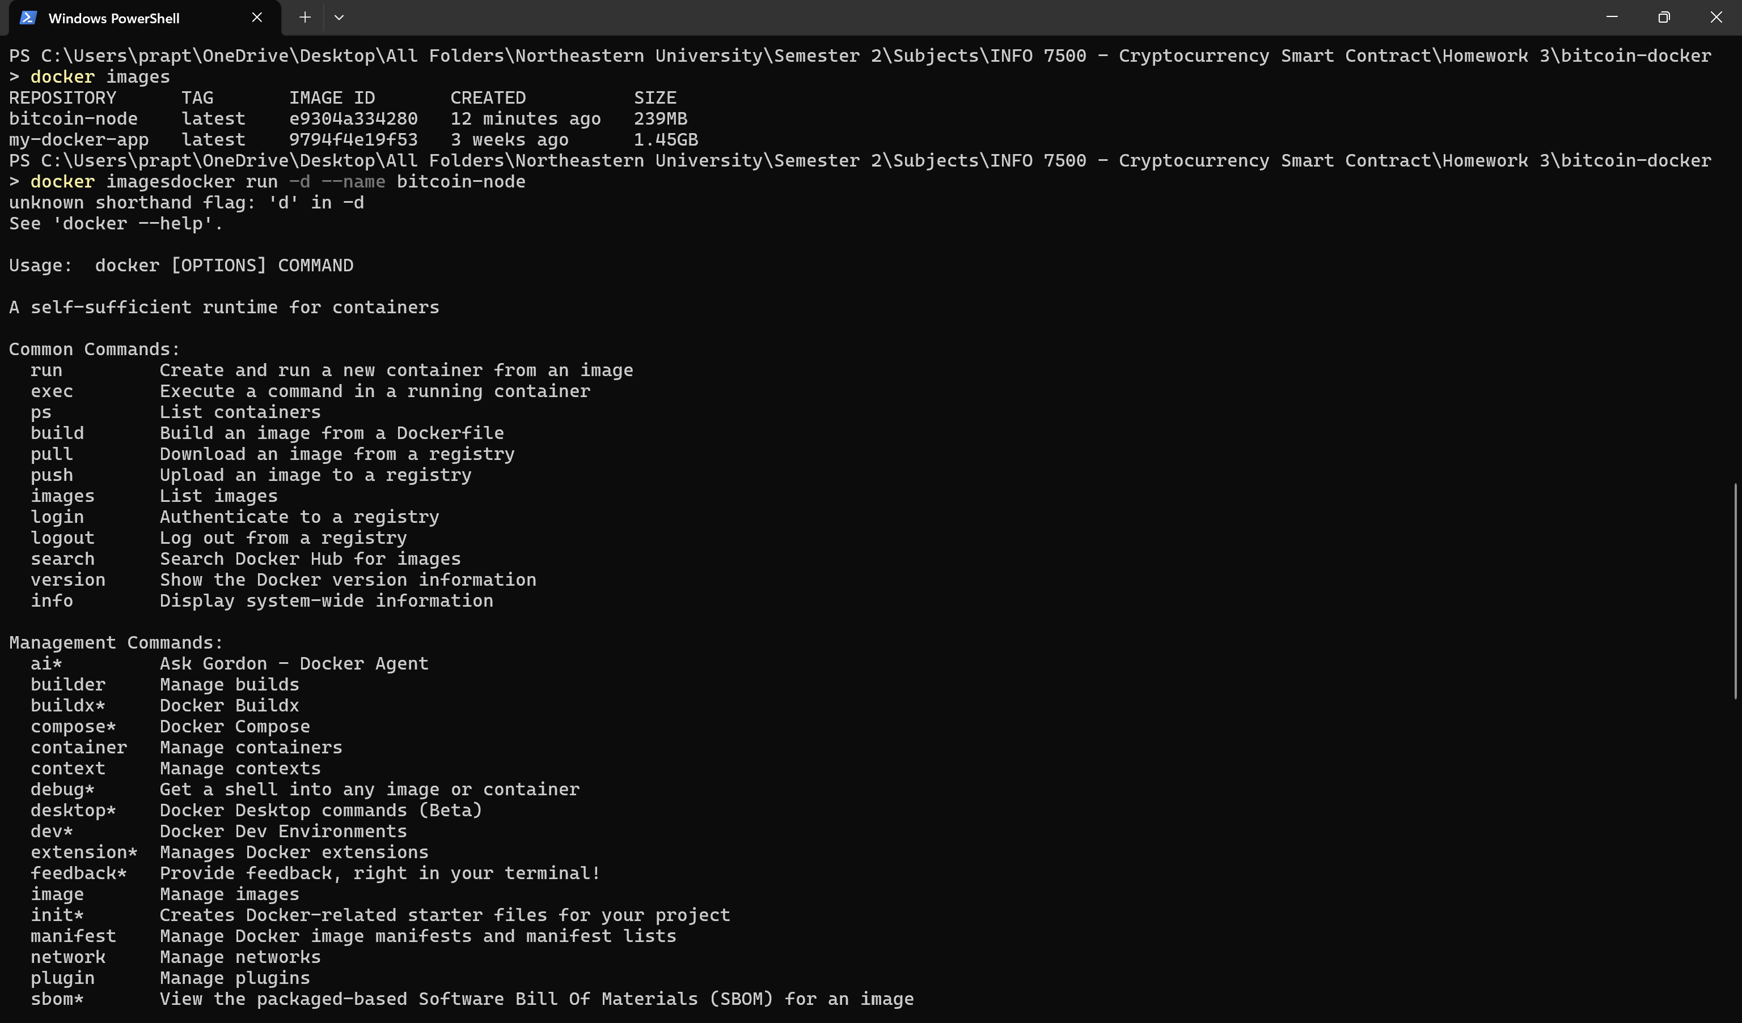

**✅ Success! Your Bitcoin Node is Running 🚀**

Your **Bitcoin node container (bitcoin_node) has started successfully** using docker-compose up -d.

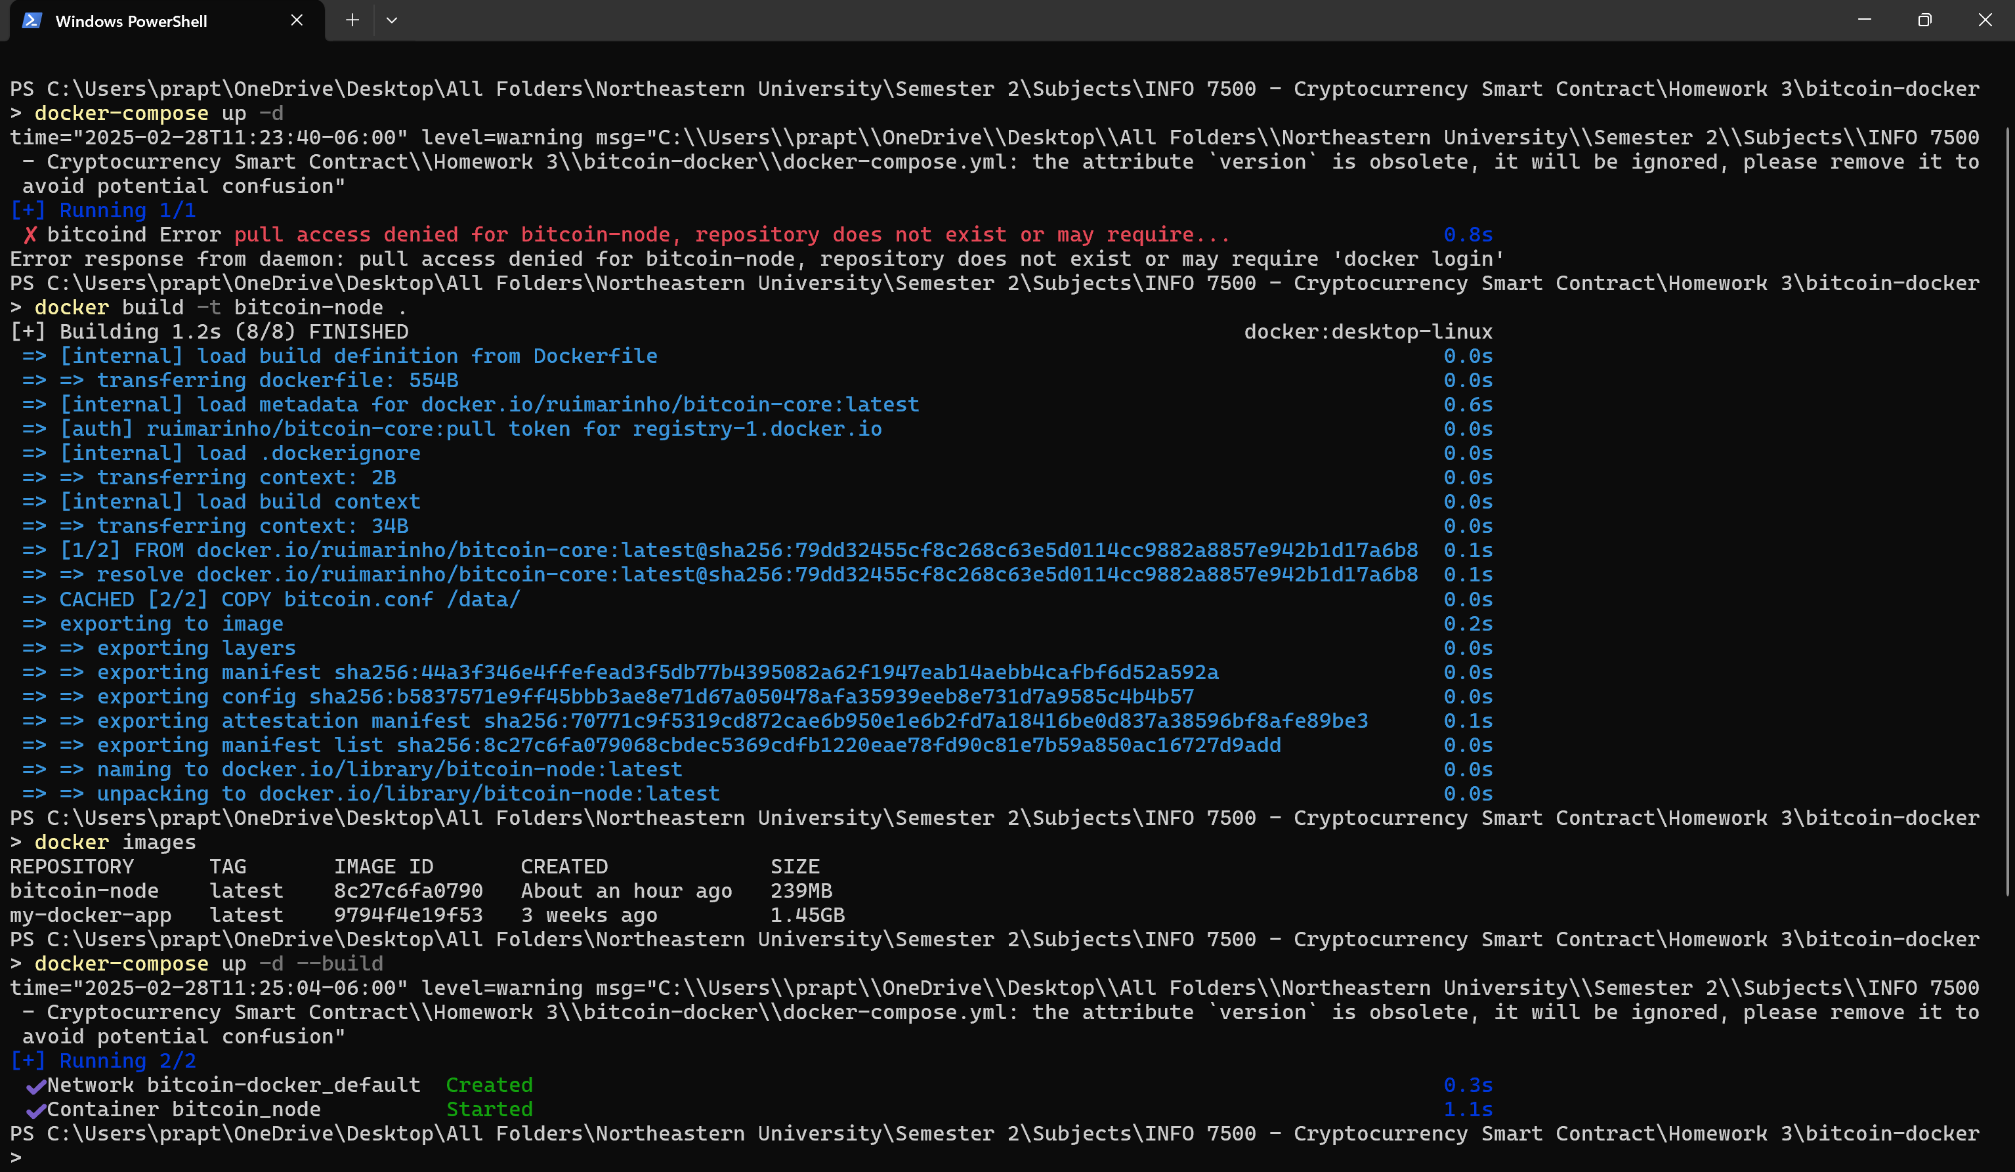

Verify the Running Container



**1. Check Synchronization Progress**

Run the following command to see how much of the blockchain is synced:

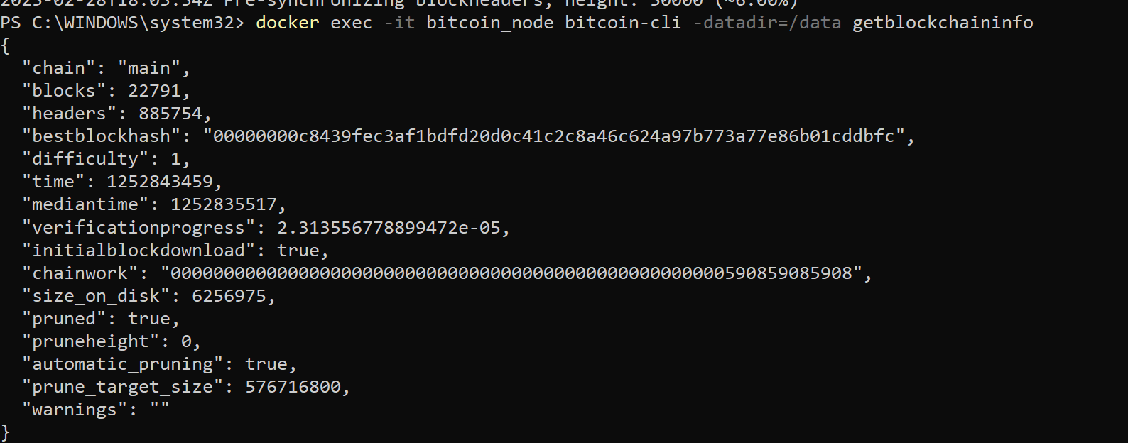

blocks is **lagging**, so node is still catching up.

**2. Verify RPC Access**

To check if node is accessible via RPC:

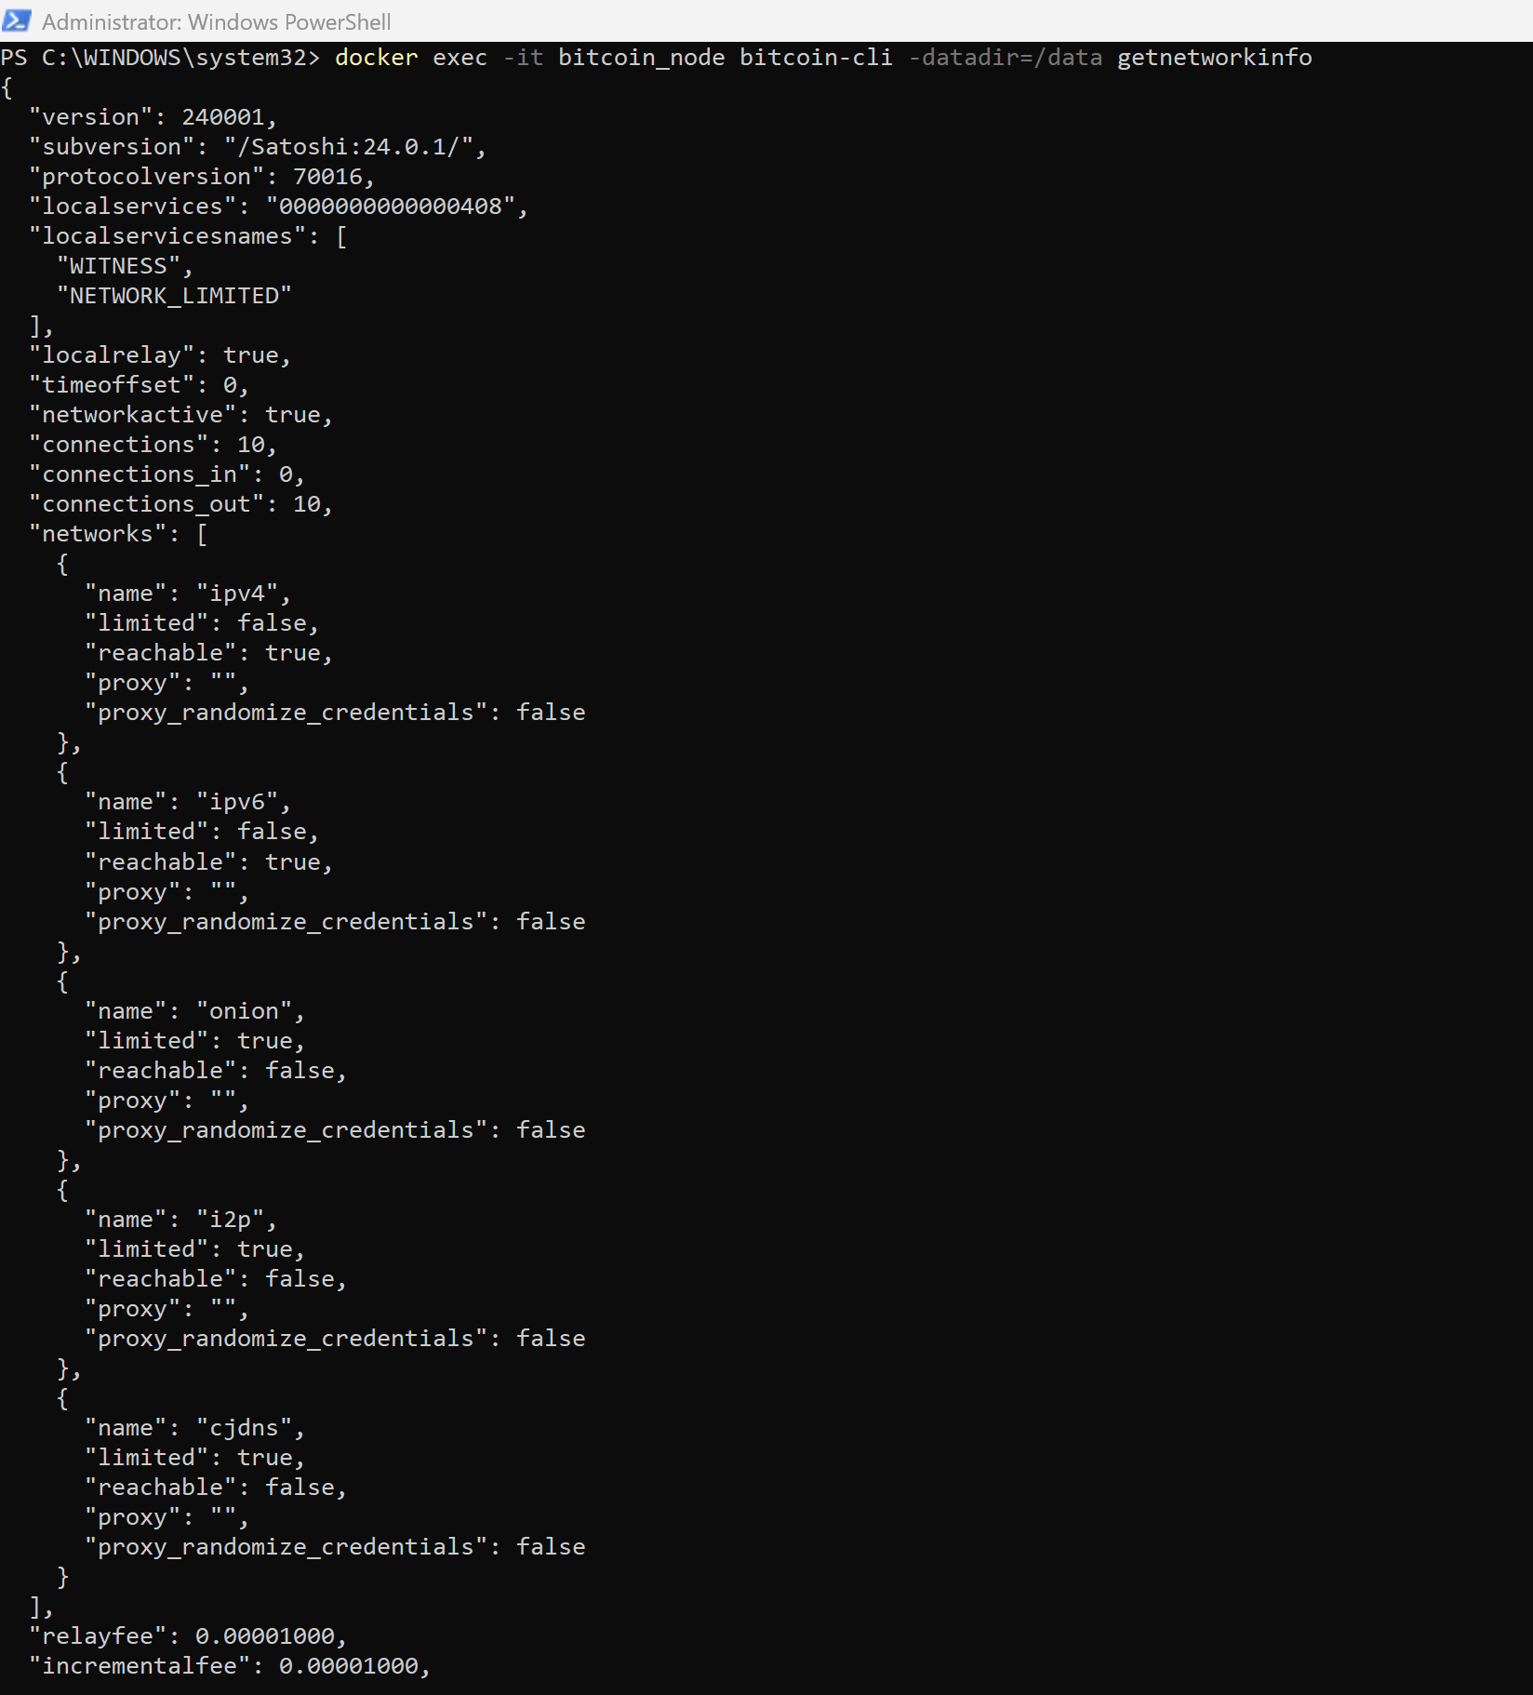

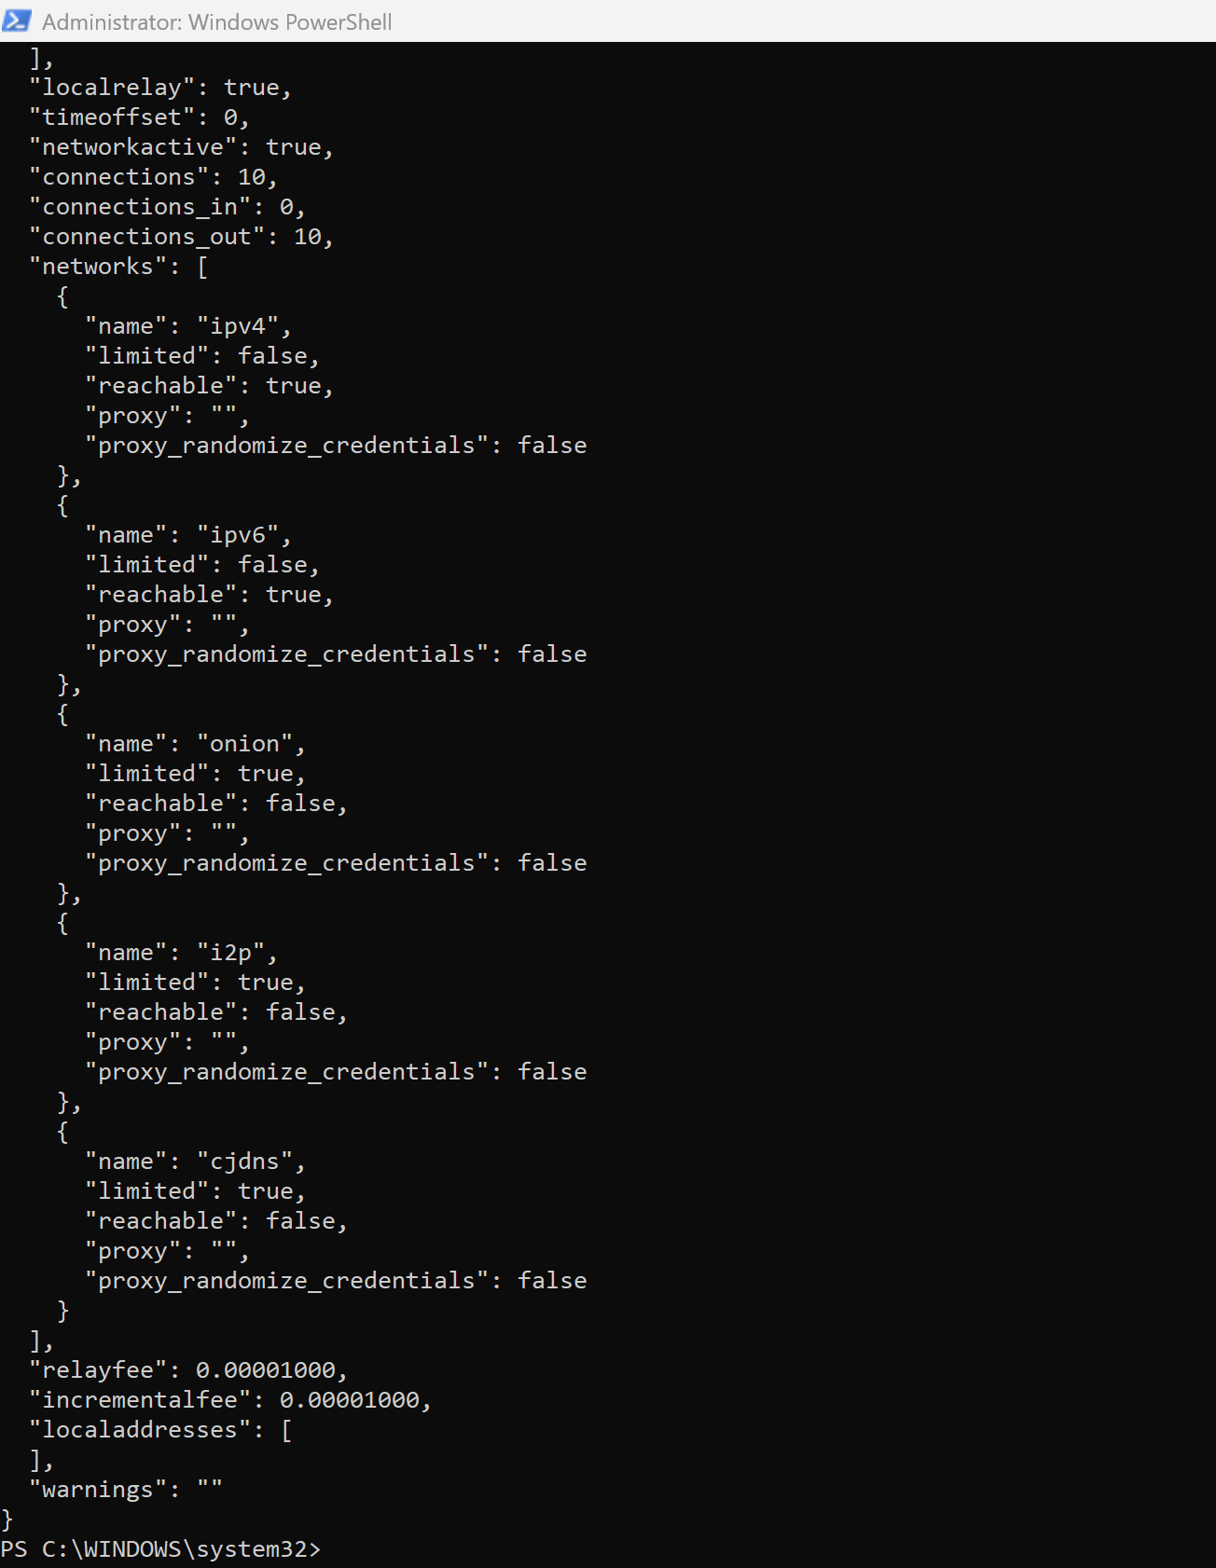

**3. Monitor Logs in Real-Time**

Keep track of progress with:

docker logs -f bitcoin_node

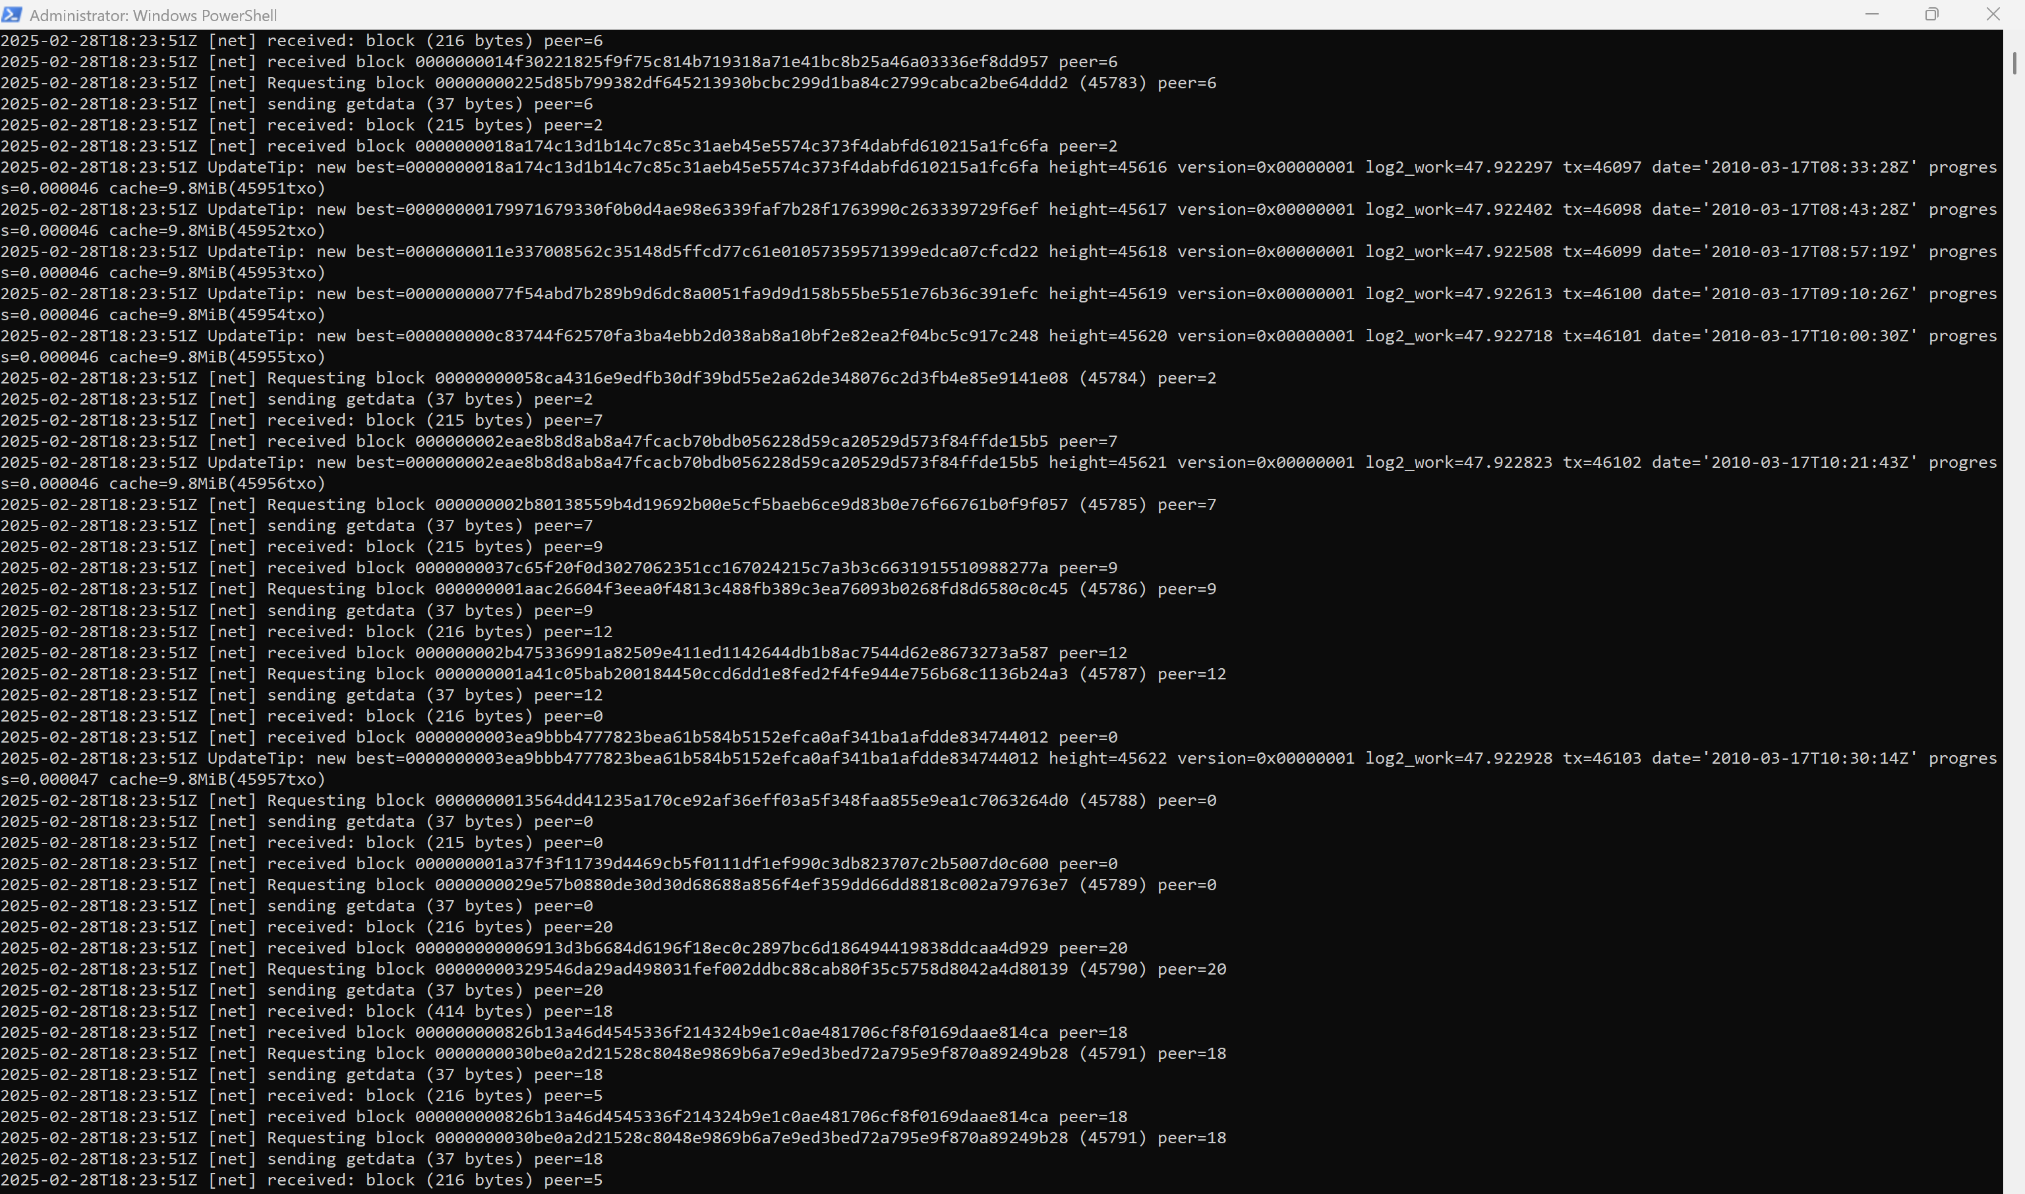

**4. Test Peer Connectivity**

Check if your node is connecting to other Bitcoin peers:

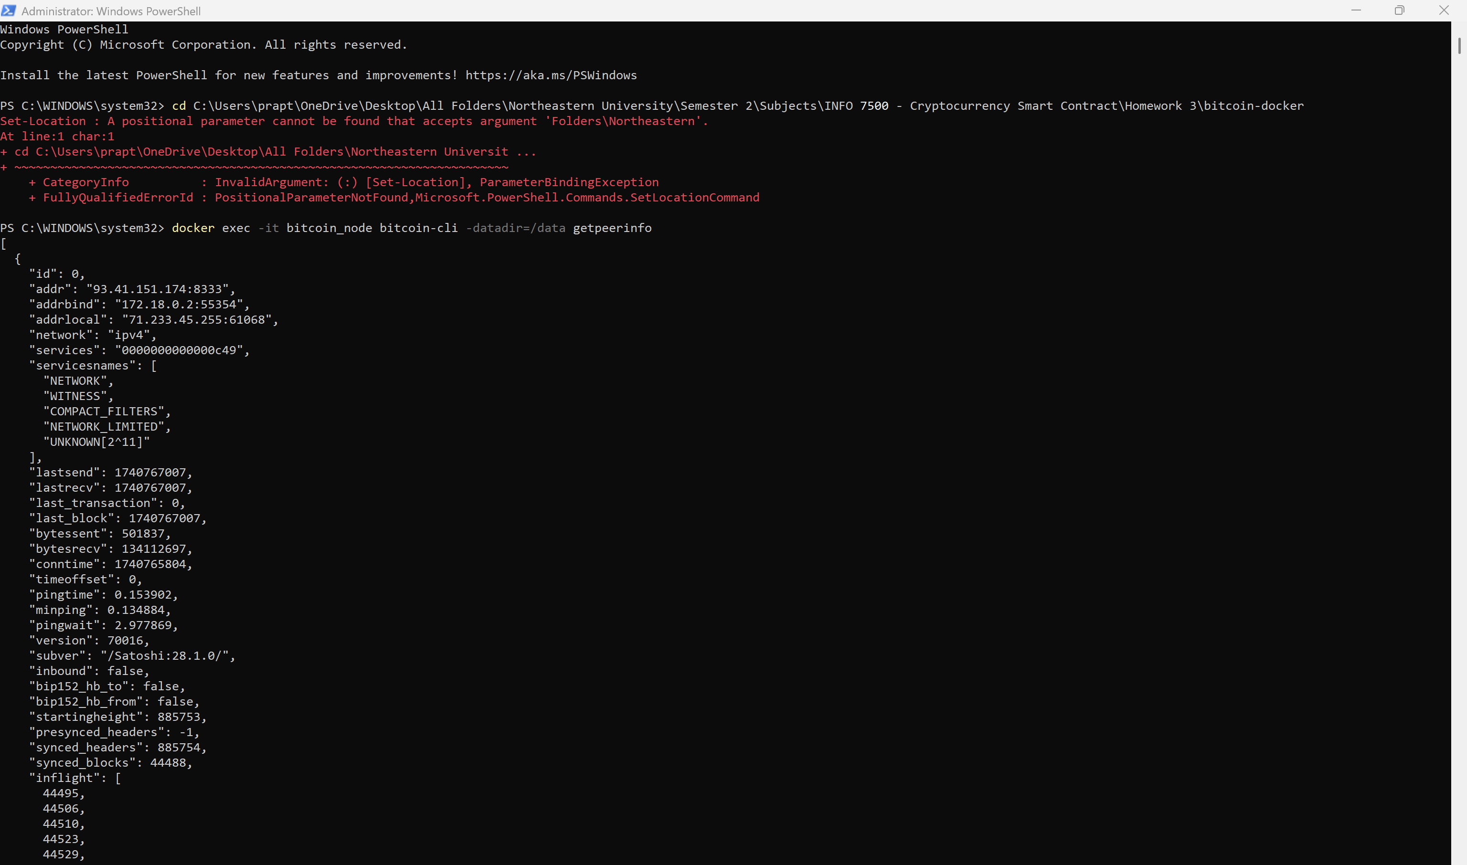

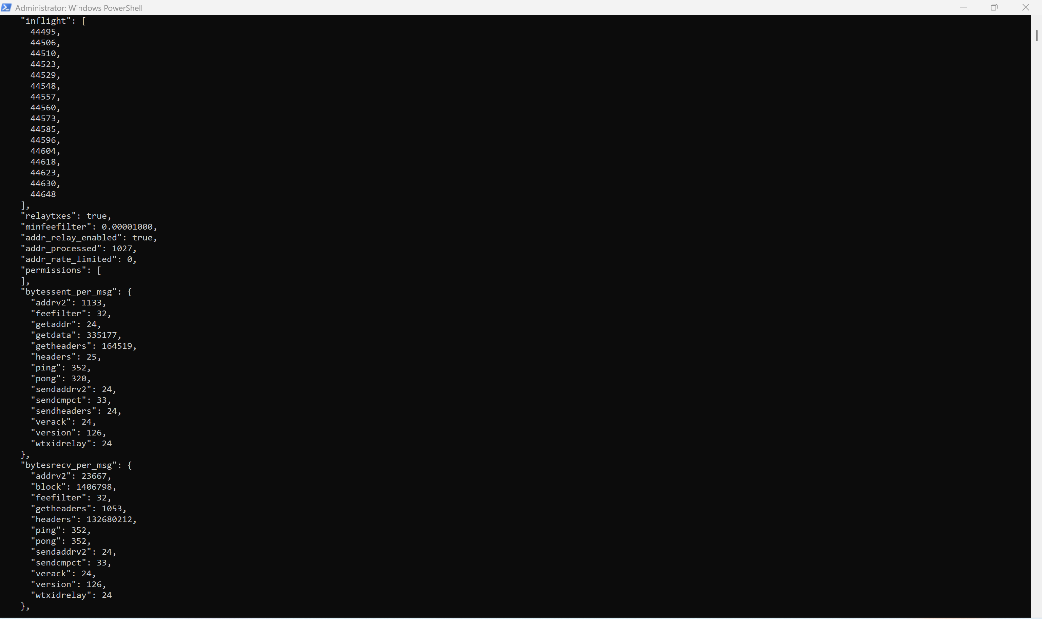

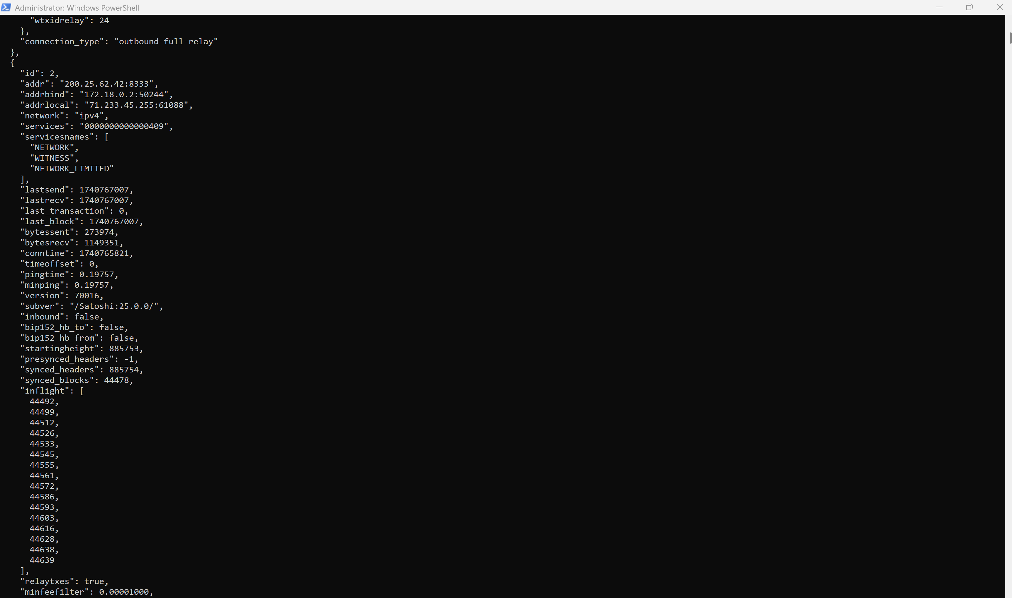

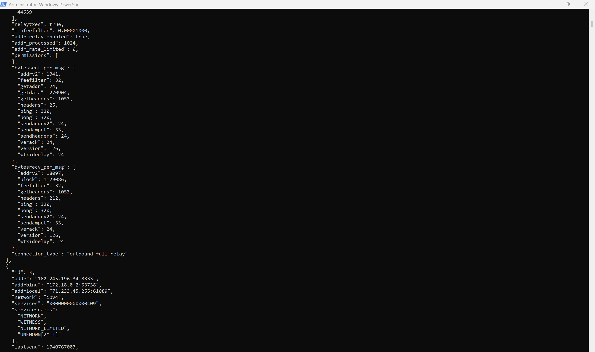

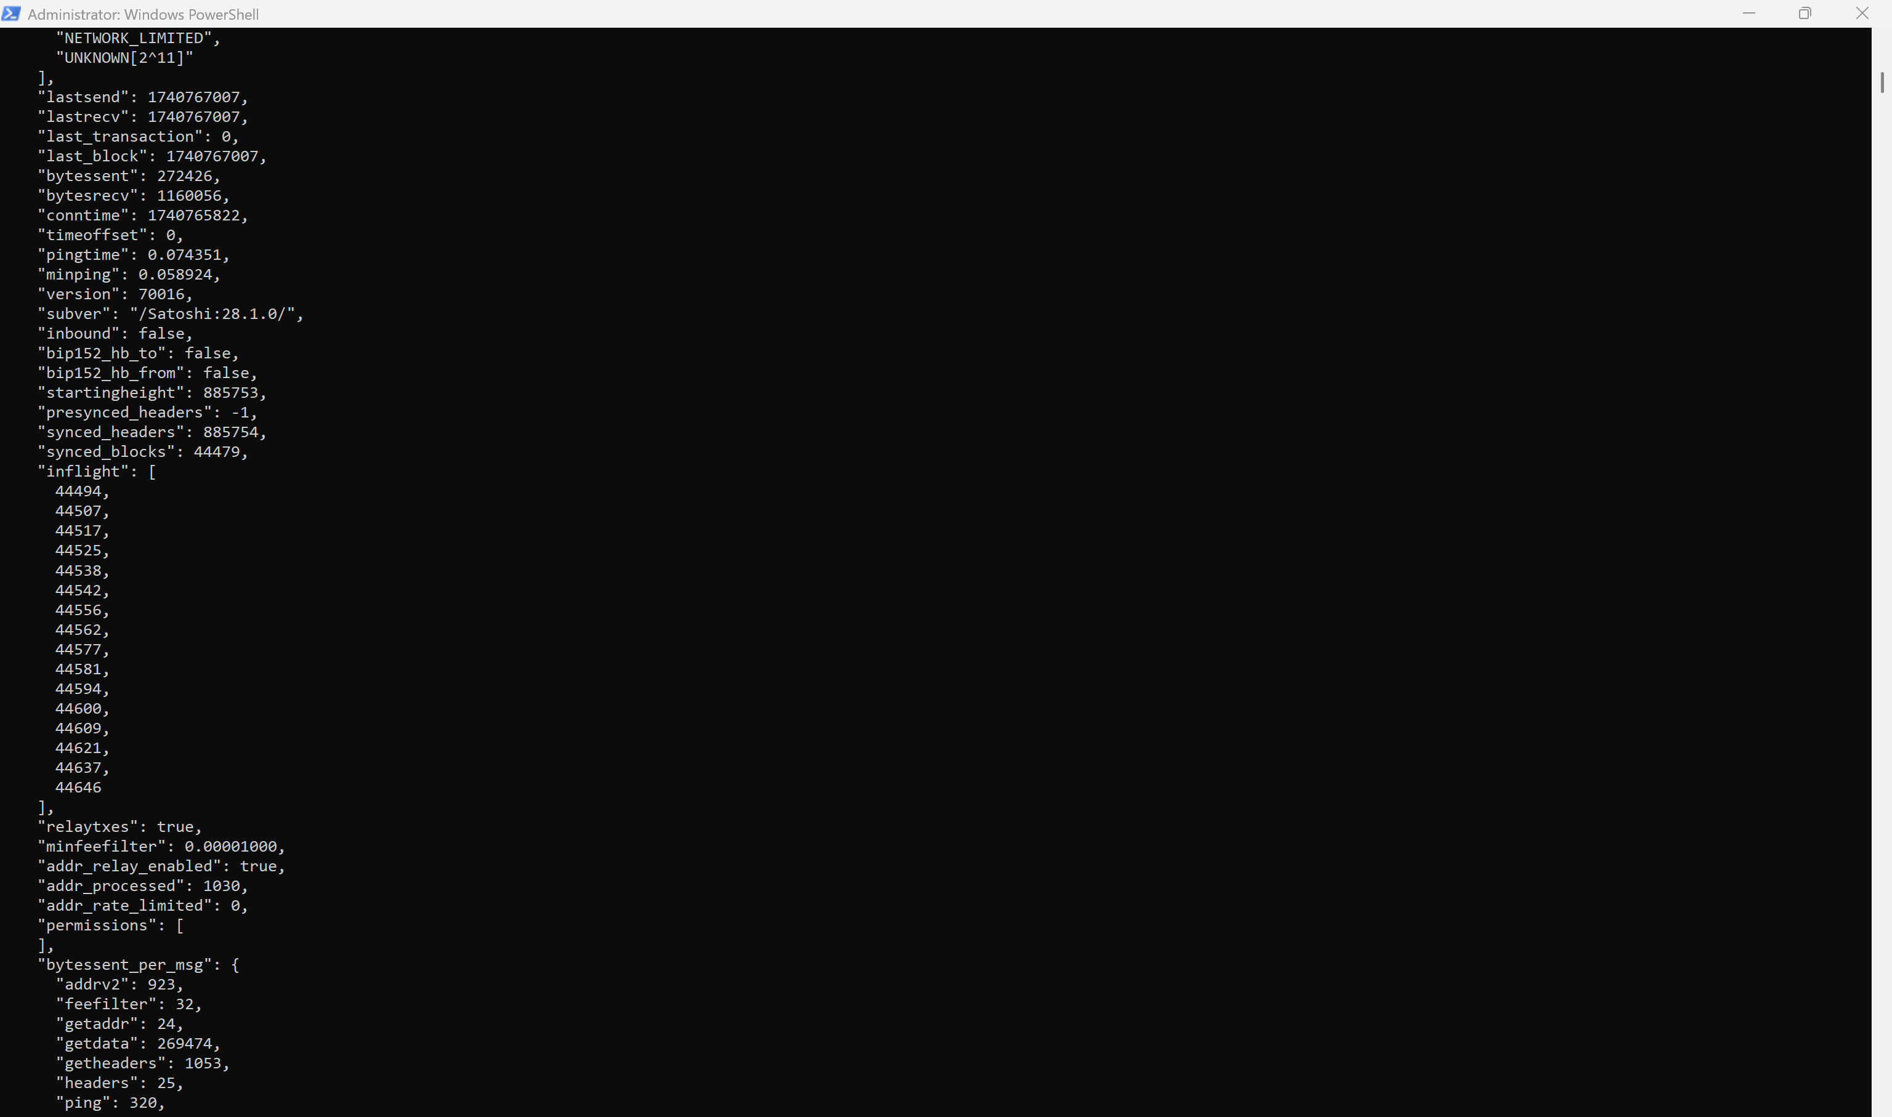

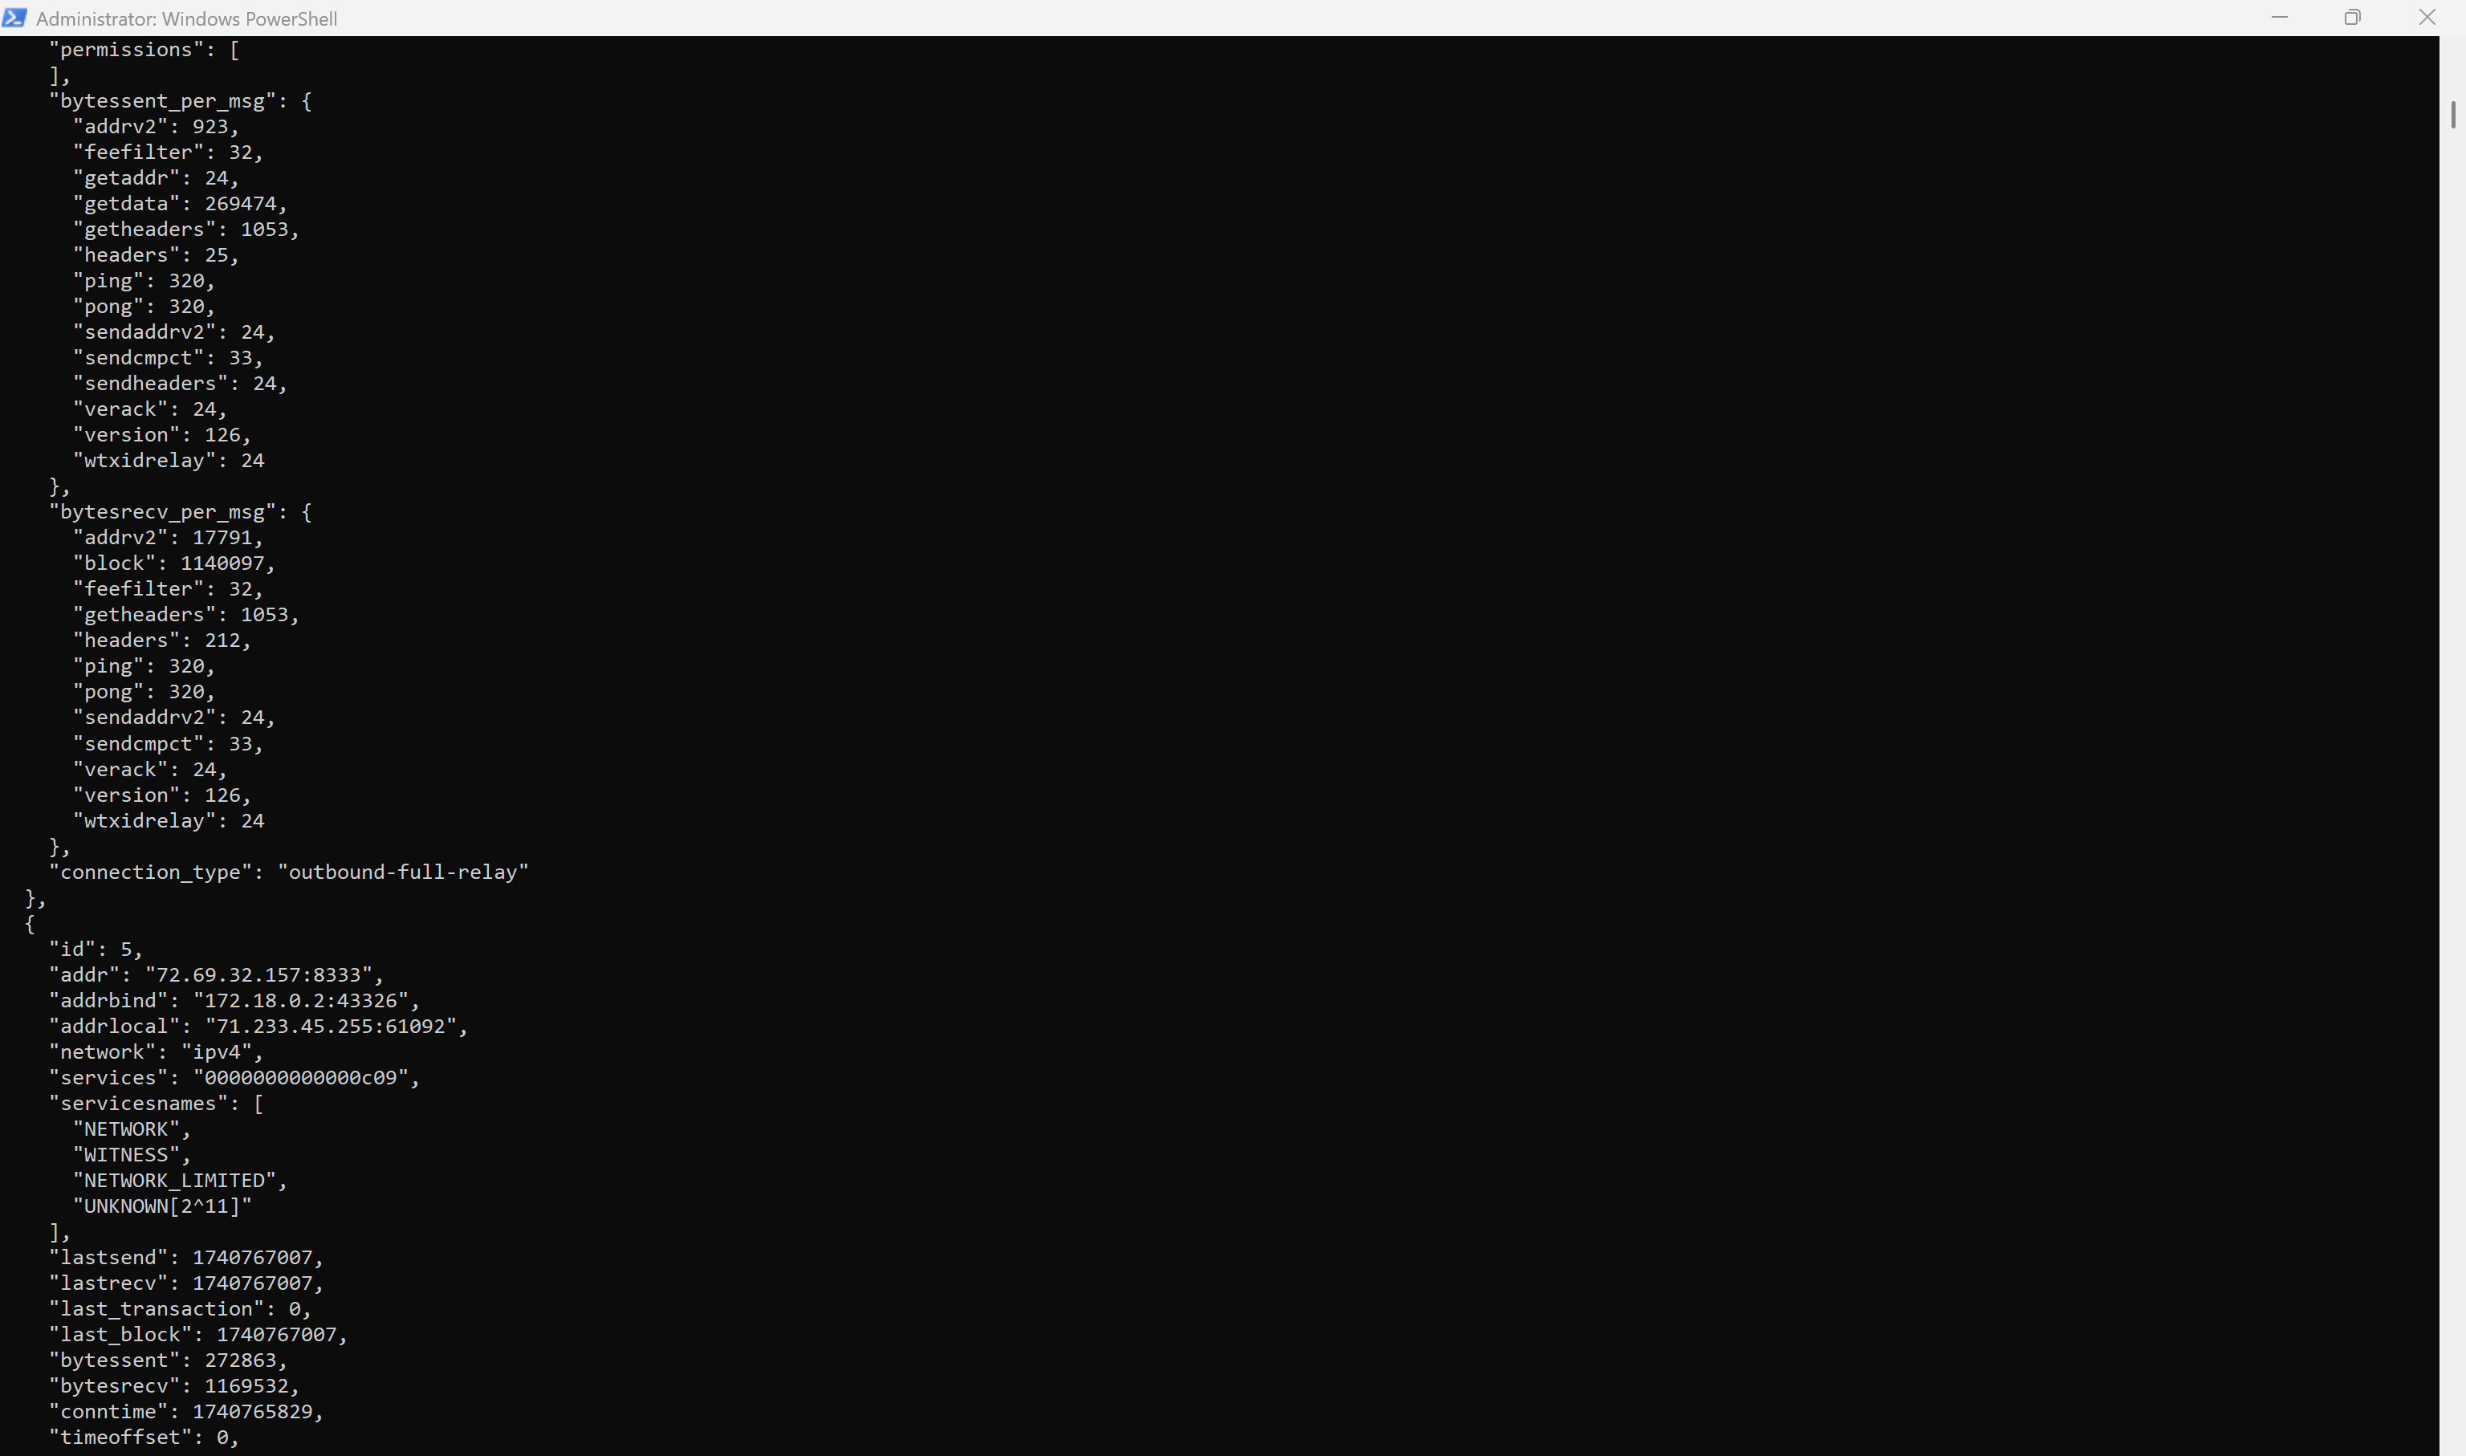

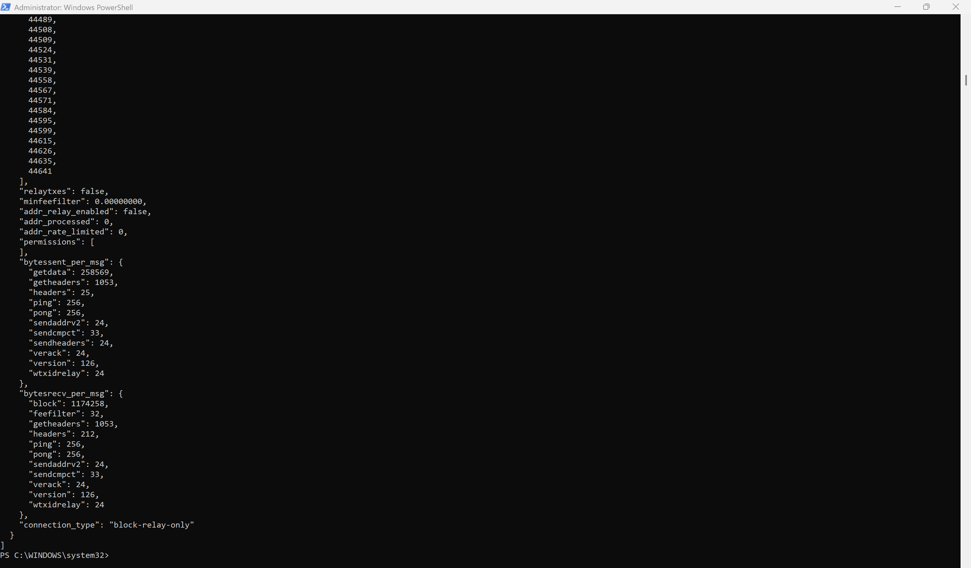

**5. Backup Your Data**

Once synced, back up the blockchain data:



**How to Restart If Needed -** docker restart bitcoin_node

**6. Verifying data persistence**

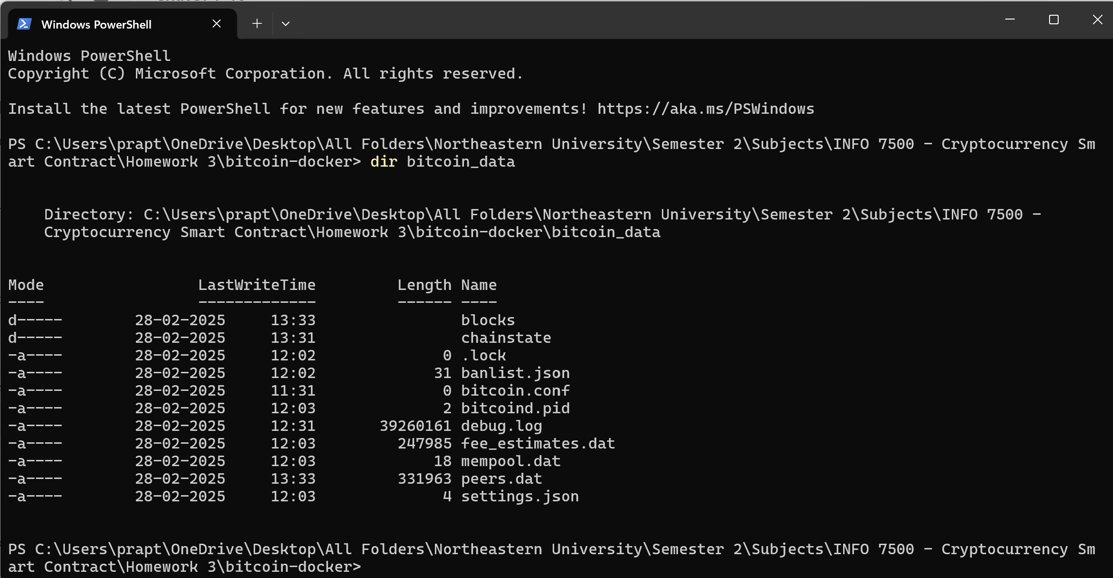

**7. Check If bitcoin_data/ Contains Files**

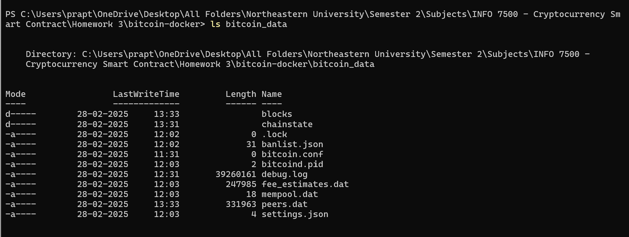

**8. Checking If the Blockchain is Downloading**

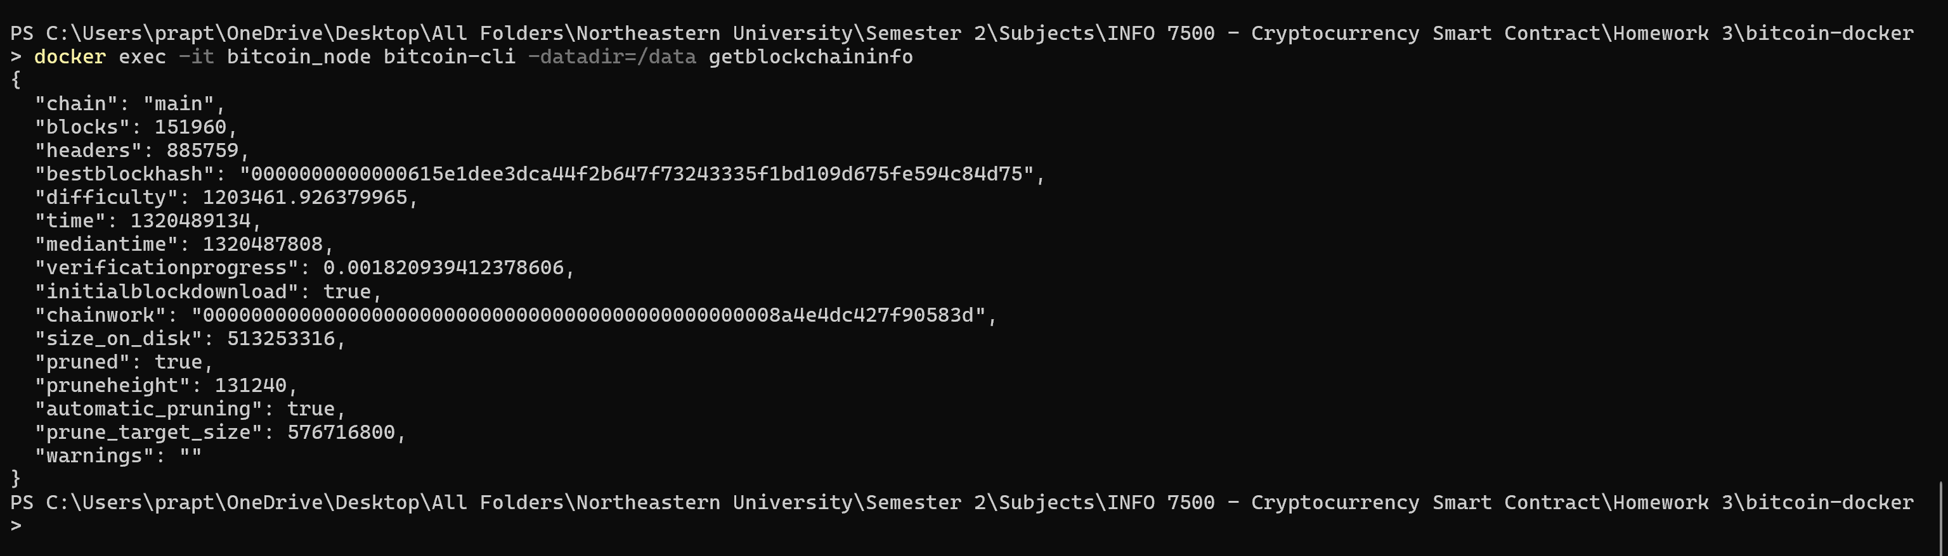

**9. Testing Persistence with a Sample RPC Call**



**1. Create a New Modal Volume**

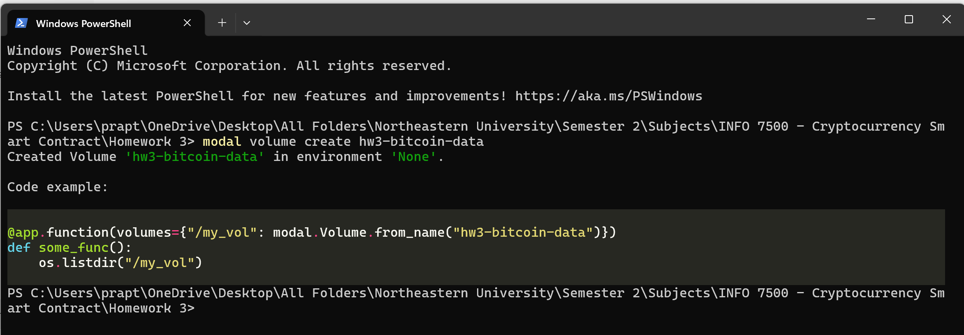

**2. Verify the Volume Creation**

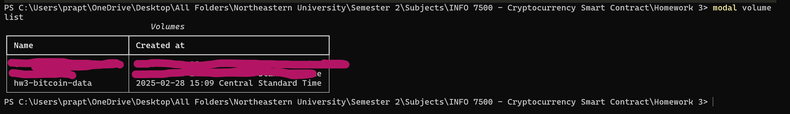

**3. Making sure Volume exists**



**4. Restarting the container with the new volume settings**

